**DAILY ONLINE ACTIVITIES SUMMARY**

|  |  |  |  |  |  |  |  |  |
| --- | --- | --- | --- | --- | --- | --- | --- | --- |
| Date: | 24/06/2020 | | | | | Name: | Jyothi B R | |
| Sem & Sec | IV-A | | | | | USN: | 4AL18CS030 | |
| Online Test Summary | | | | | | | | |
| Subject | | N/A. | | | | | | |
| Max. Marks | | -- | | Score | | | -- | |
| Certification Course Summary | | | | | | | | |
| Course | Programming Essentials in Python | | | | | | | |
| Certificate Provider | | | Cisco Virtual Academy | | Duration | | | 3hrs |
| Coding Challenges | | | | | | | | |
| |  |  | | --- | --- | | Problem statement : Problem 1: (using Python) [Program to Split the array and add the first part to the end. An array of numbers is taken as input and split it from a specified position, and move the first part of array add to the end.](https://github.com/orgs/alvas-education-foundation/teams/2nd-year/discussions/135) |  | | | | | | | | | |
| Status:Completed | | | | | | | | |
| Uploaded the report in Github | | | | | Yes | | | |
| If yes Repository name | | | | | https://github.com/alvas-education-foundation/jyothi_b_r | | | |
| Uploaded the report in slack | | | | | Yes | | | |

Online Test Details: (Attach the snapshot and briefly write the report for the same)

Certification Course Details: (Attach the snapshot and briefly write the report for the same)

Coding Challenges Details: (Attach the snapshot and briefly write the report for the same)

**ONLINE TEST DETAILS: NOT CONDUCTED.**

CERTIFICATION COURSE DETAILS:

Programming Essentials in Python :

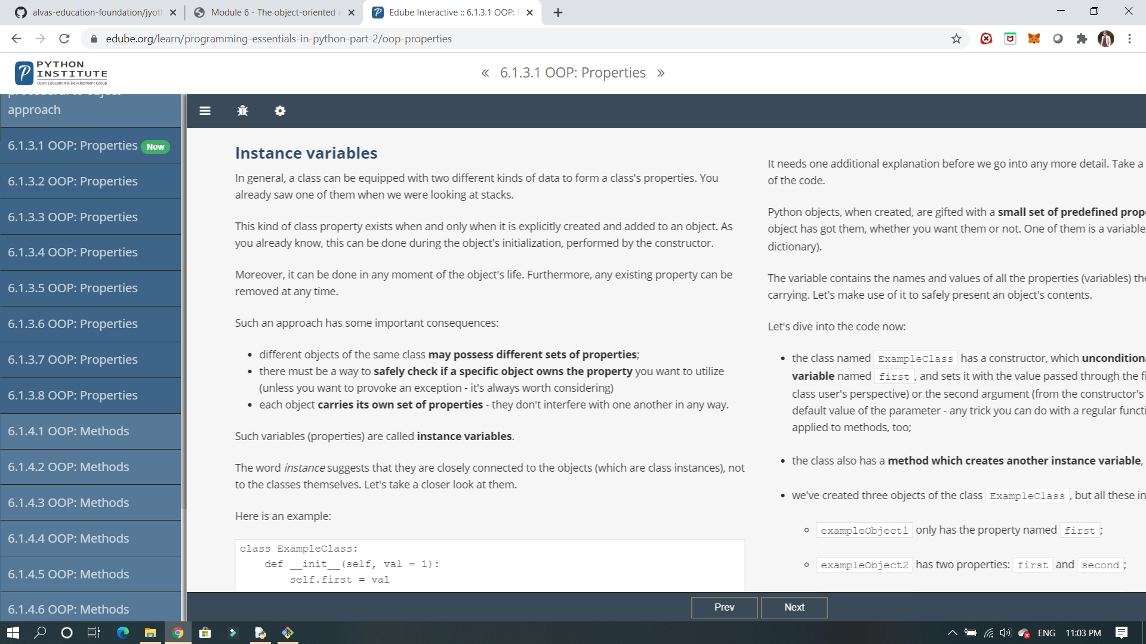

IT’S A NEXT MODULE ,IT SHOWS ABOUT THE OBJECT ORIENTED APPROCH AND FOUNDATIONS.

And it shows about the object approach and about stack and it shows the implementation for variables how it can be used.

ONLINE CODING Problem 1: (using Python) [Program to Split the array and add the first part to the end. An array of numbers is taken as input and split it from a specified position, and move the first part of array add to the end.](https://github.com/orgs/alvas-education-foundation/teams/2nd-year/discussions/135)

